FOOD RECOMMENDATION

**Dipen Joshi1, Priyanka Patel** **2**

12Smt. Kundanben Dinsha Patel  Department of Information Technology ,Chandubhai S Patel Institute of Technology, CHARUSAT University, India.

1. **ABSTRACT**

In recent times, choosing the right hotel and booking accommodation has become a major issue for travelers. Online hotel searches have expanded at a faster rate and were more tedious because of the measure of data accessible on the web. Recommender frameworks are progressively significant due to their significance in settling on choices and giving nitty gritty data about the item or administration required. Getting hotel recommendations while reviewing textbook reviews, pricing, votes, ratings, and video viewing numbers has been difficult. To create dependable proposals, we have built up a savvy approach that additionally addresses the bigger subtleties of size to address the issues of possible clients. Community oriented separating (CF) is one of the most mainstream ways for RS to make proposals. We have proposed a CF tale suggestion technique where supposition based enthusiastic investigation is utilized to accomplish an inn angle lattice with extremity distinguishing proof. Our methodology incorporates punctuation examination, sentence structure investigation, and semantic examination to comprehend emotions towards inn highlights and visitor type prints (yesterday, family, couples and so on The serious not just figures out how to oversee special information utilizing Hadoop's enormous information stage yet in addition suggests the lodging classification relying upon the kind of visitors utilizing unambiguous standards.

* **Keyword:** food, recommendation, online system, nutritional value.

1. **INTRODUCTION**

In the current period of web innovation advancement, special frameworks (RSs) have reacted to the notice of the business network and the overall population all in all because of their significance and significance in web based business and in picking up the assent of predominant clients. These days web based business is accepted to be firmly connected to consumer loyalty, and incredible achievement consistently relies upon client unwaveringness. The equivalent is valid for web based booking and booking programs that are a significant piece of the travel company. contended that the most remarkable and famous industry has the greatest effect on the general GDP of the worldwide the travel industry economy. Guests from everywhere the world are continually searching for the best lodgings to remain in during the visit that keeps the proposal frameworks as their primary choices to locate the best inn booking alternatives online before they show up at their objective to evade any future inn issues.

The sheer volume of information on the Internet and on the web daunting task, but it is also a barrier to complimenting or complimentary-compliant-Complex information in numerous structures, for example, numbers, text, and visuals requires the consideration of designers to create frameworks that suggest managing information varieties. noticed that as of late there have been a couple of proposals in the market with some intricate information taking care of abilities where they have utilized the outcomes acquired from client input yet do exclude audits, votes, evaluations, and video sees on client criticism accessible via online media. In this proposed approach, we have likewise executed numerous client cuts, for example, votes and YouTube video sees. Our suggested free program offers a twofold norm and advantages; first, it utilizes the lodging highlight network to prescribe the correct inn to the client based on amount (numbers) and quality (text) highlights by utilizing AI characterization to accomplish genuine proposals; draws client logical data and eliminates impressions from audits by breaking down other explorer surveys and rankings, votes, and YouTube video perspectives to improve the precision of the suggestion. Second, the vague module gives a suggestion to certain client type lodgings, for example, solo, family, business, companions, and sweethearts since proposals will change contingent upon the kind of client outing and client inclinations. Similarly as with family, "room," "food," and "cleanliness" are the most famous things yet for one guest, offices, for example, "pool," "spa", and "exercise center" can be particular. Likewise "WiFi" and "PC" can be a significant factor for a business explorer.

Recommendation programs were designed to deliver accurate and relevant recommendations. A good recommendation means a recommendation that goes with the preferences and preferences of the customer. Typically, the suggestion framework utilizes client appraisals and updates from past information considering the characteristics or highlights of the inn. So the greatest test in this paper is to build up a smart method of handling and investigating huge diverse web information to accomplish sensible inn proposals that are steady with client decision

While we were confronted with an assortment of information in our multi-lodging proposal framework, the greatest test was to mine investigation/client criticism audits to compute the extremity rating speaking to the degree of likeness or aversion of the inn by the client. The overall proposal is generally counts on past client appraisals about lodging signs or highlights, however our suggested proposal additionally utilizes surveys, number-level votes, and video perspectives to catch the genuine consequences of different client reports. The extremity focuses give the content side of the client's assessment about a specific inn. To deal with novel information variety as the submitted technique utilizes mathematical and text information, an enormous information arrangement including Hadoop has been utilized in our methodology since it handles information variety and information variety in a superior manner. We portrayed the sort of guest as the fundamental piece of examination. We won't just glance at the diverse rating boundaries however will likewise utilize the circumstance investigation dependent on client surveys. For instance, Trip Advisor permits voyagers to rate lodgings with numerous choices, for example, area, room, neatness, administration and staff. The way toward separating thoughts from printed surveys is called editorial/sentiment examination.

Many lessons in emotional analysis books on modern ways of holding reviews to give recommendations. Electronic reading is one of the most effective ways of sorting emotional texts divided into constructive, negative, or impartial classes. AI techniques, preparing and testing informational indexes are basic. The preparation site is utilized to peruse the archives, and the test information base is utilized to check execution. There are four fundamental sorts of AI to order refreshes.

The primary motivation behind our proposal program is to give proposals and suggestions dependent on client inclinations and inclinations. zeroed in on the nature of the suggestions. It is proposed by the creator that when countless client appraisals and audits are utilized for investigation to give powerful and exact suggestions, at that point the nature of the proposals is significant. Online appointments and proposals have expanded as of late, and global associations are chipping away at this website to take advantage of it. The Recommendation System (RS) helps clients find reasonable inns as well as profit by all areas, for example, films, books, and a wide range of special items and things. Different kinds of information, specifically, lodgings, motion pictures, and music, can be prepared by RS. A common commendation structure is appeared in Figure 1. Burke talked about the various sorts of praises. Clarify that there are two different ways to compliment.

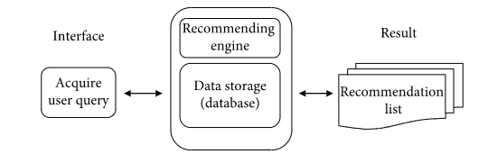

1. **RELATED WORKS**

Past business related to the proposal cycle is examined in this segment. Past examination portrays viable ideas of praises, for example, data channels and suggestion calculations that have been utilized to make free projects that help to comprehend and know the requirement for praises in the current web innovation.

The Food Recommendation Framework is suggested for diabetic patients who have utilized K-mean bunching and Self-Organing Map for dietary enhancement investigation. The proposed arrangement suggests substitution nourishments as far as sustenance and dietary limitations. Notwithstanding, FRS doesn't satisfactorily address the issue of illness status since glucose levels can change by hour in various patient conditions and dietary proposals may shift in like manner. Labels and latents are utilized for the Android-based food suggestion program. The framework suggests a customized formula for the client dependent on labels and evaluations gave at client inclinations. The proposed framework utilized vectors for shrouded highlights and grid factorization in their calculation. Consistency exactness is accomplished using labels that are firmly identified with clients' proposals and inclinations. Nonetheless, the creators don't consider sound food things so as to adjust the client's eating routine as indicated by their necessities. It is suggested a substance based food proposal framework that prescribes food plans as per client inclinations. Client inclinations plans are separated into measurement fixings as indicated by the inclinations of the spared clients. Plans with a similar fixing are suggested. The creators don't consider the supplements and equilibrium in the eating regimen. Likewise, open doors for comparable suggestions additionally exist since client inclinations may not change each day. In, a nourishing suggestion framework dependent on heftiness data is proposed.

1. **Recommender system**

Food Promotion Programs help end clients help discover the items and administrations they need. have proposed a physical subtitling technique, called reverberation similitude (RES), as another strategy. This tale comparability gives higher theory contrasted with the customary likeness estimates utilized for client testing. examined how lopsided things can be suggested and anticipated utilizing distinctive separating methodologies, and led research utilizing the Trip Advisor travel information base. Furthermore, they presented a half and half methodology that utilizes estimation information and text substance to foresee client execution. Crespo et al. examine how Sem-Fit uses client criticism to utilize consistent approaches to talk about client and lodging highlights, spoken to by space ontologies and influence grids.

1. **SNAPSHOT**

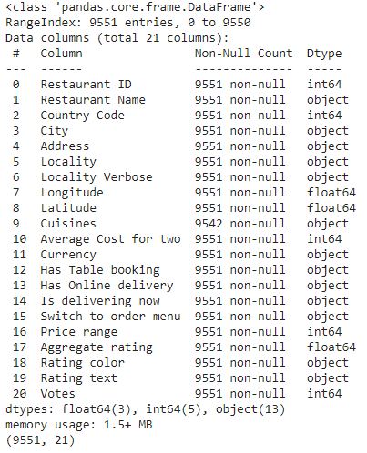

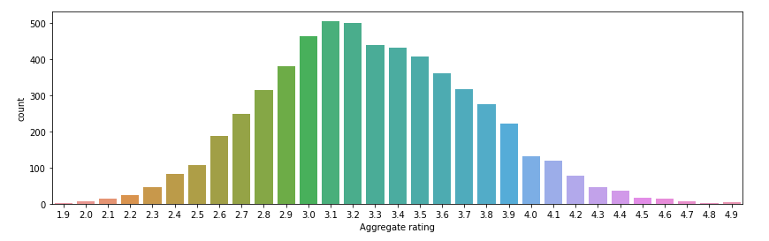

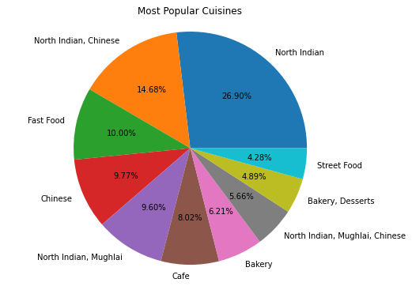

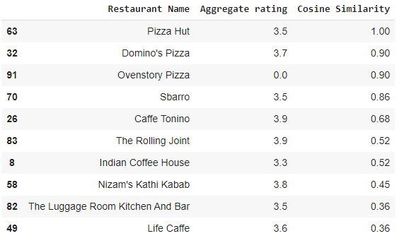

A Food Recommendation System (FRS) [8] is proposed for diabetic patients that used K-mean

clustering and Self-Organizing Map for clustering analysis of food. The proposed system

recommends the substituted foods according to nutrition and food parameters. However, FRS

does not adequately address the disease level issue because the level of diabetes may vary

hourly in different situations of the patient and the food recommendations may also vary

accordingly. Tags and latent factor are used for android based food recommender system [9].

The system recommends personalized recipe to the user based on tags and ratings provided in

user preferences. The proposed system used latent feature vectors and matrix factorization in

their algorithm. Prediction accuracy is achieved by use of tags which closely match the

recommendations with users’ preferences. However, the authors do not consider the nutrition

factors in order to balance the diet of the user according to his needs. Content based food

recommender system [10] is proposed which recommend food recipes according to the

preferences already given by the user. The preferred recipes of the user are fragmented into

ingredients which are assigned ratings according to the stored users’ preferences. The recipes

with the matching ingredient are recommended. The authors do not consider the nutrition

factors and the balance in the diet. Moreover, chances of identical recommendation are also

present because the preference of the user may not change on daily basis. In [31], knowledge

based dietary nutrition recommendation system is proposed for obesity.

A Food Recommendation System (FRS) [8] is proposed for diabetic patients that used K-mean

clustering and Self-Organizing Map for clustering analysis of food. The proposed system

recommends the substituted foods according to nutrition and food parameters. However, FRS

does not adequately address the disease level issue because the level of diabetes may vary

hourly in different situations of the patient and the food recommendations may also vary

accordingly. Tags and latent factor are used for android based food recommender system [9].

The system recommends personalized recipe to the user based on tags and ratings provided in

user preferences. The proposed system used latent feature vectors and matrix factorization in

their algorithm. Prediction accuracy is achieved by use of tags which closely match the

recommendations with users’ preferences. However, the authors do not consider the nutrition

factors in order to balance the diet of the user according to his needs. Content based food

recommender system [10] is proposed which recommend food recipes according to the

preferences already given by the user. The preferred recipes of the user are fragmented into

ingredients which are assigned ratings according to the stored users’ preferences. The recipes

with the matching ingredient are recommended. The authors do not consider the nutrition

factors and the balance in the diet. Moreover, chances of identical recommendation are also

present because the preference of the user may not change on daily basis. In [31], knowledge

based dietary nutrition recommendation system is proposed for obesity.

A Food Recommendation System (FRS) [8] is proposed for diabetic patients that used K-mean

clustering and Self-Organizing Map for clustering analysis of food. The proposed system

recommends the substituted foods according to nutrition and food parameters. However, FRS

does not adequately address the disease level issue because the level of diabetes may vary

hourly in different situations of the patient and the food recommendations may also vary

accordingly. Tags and latent factor are used for android based food recommender system [9].

The system recommends personalized recipe to the user based on tags and ratings provided in

user preferences. The proposed system used latent feature vectors and matrix factorization in

their algorithm. Prediction accuracy is achieved by use of tags which closely match the

recommendations with users’ preferences. However, the authors do not consider the nutrition

factors in order to balance the diet of the user according to his needs. Content based food

recommender system [10] is proposed which recommend food recipes according to the

preferences already given by the user. The preferred recipes of the user are fragmented into

ingredients which are assigned ratings according to the stored users’ preferences. The recipes

with the matching ingredient are recommended. The authors do not consider the nutrition

factors and the balance in the diet. Moreover, chances of identical recommendation are also

present because the preference of the user may not change on daily basis. In [31], knowledge

based dietary nutrition recommendation system is proposed for obesity.

1. **STUDENT LEARNING**

This examination accentuates the elements of the proposed increase program, and its adequacy actually should be affirmed by taking a gander at understudy practices and results in reality e-learning climate. In future examination, the framework will likewise be extended to oblige different projects in the e-learning region. Moreover, an innovation selection model will be utilized in future work to evaluate the appropriation and usage of the proposed framework.

1. **CONCLUSION**

In this paper, we have presented a cloud-based dietary proposals called Diet-Right. In view of our incorporation, it suggests a rundown of solid nourishments utilizing the ACO model. Diet-Right directs and updates heuristic subtleties so that food variety is amplified. Profoundly performed tests are performed to evaluate cost, precision, meeting time, and execution gains. As a future report, we will zero in on separating suggestions for various times, for example, breakfast, lunch and supper. Also, we will take a gander at the measure of supplements in an assortment of dietary things as per the time and day by day needs of patients. What's more, gathering/companions bunch supper proposals are another energizing zone for research that can be investigated. With diabetes care, a solid eating regimen is the way to controlling diabetes. Nonetheless, the current strategy for arrangement doesn't function admirably in ordering a diabetic eating regimen. In a past report a cosmology was proposed with respect to diabetes care and a reasonable eating routine, however the outcomes couldn't accomplish dietary factors.

1. **REFERANCE**
2. M. M. Mariani, D. Buhalis, C. Longhi, and O. Vitouladiti, “Managing change in tourism destinations: key issues and current trends,” *Journal of Destination Marketing and Management*, vol. 2, no. 4, pp. 269–272, 2014.View at: <https://www.sciencedirect.com/science/article/pii/S2212571X13000577>
3. H. Liu, J. He, T. Wang, W. Song, and X. Du, “Combining user preferences and user opinions for accurate recommendation,” *Electronic Commerce Research and Applications*, vol. 12, no. 1, pp. 14–23, 2013

[**https://www.sciencedirect.com/science/article/pii/S1567422312000312**](https://www.sciencedirect.com/science/article/pii/S1567422312000312)

1. J. J. Zhang and Z. Mao, “Image of all hotel scales on travel blogs: its impact on customer loyalty,” *Journal of Hospitality Marketing and Management*, vol. 21, no. 2, pp. 113–131, 2012.View at:

[**https://www.tandfonline.com/doi/abs/10.1080/19368623.2011.615017**](https://www.tandfonline.com/doi/abs/10.1080/19368623.2011.615017)

1. Y. Koren, R. Bell, and C. Volinsky, “Matrix factorization techniques for recommender systems,” *Computer*, vol. 42, no. 8, 2009.

[**https://ieeexplore.ieee.org/abstract/document/5197422**](https://ieeexplore.ieee.org/abstract/document/5197422)

